An Adjustable Module Using Korematsu v. United States
To Teach Students About The Role of Lawyers
During Law School Orientation Or Introduction to Law

Korematsu v. United States, is one of the most well-known cases in American legal history. In addition to what it teaches about the development of legal doctrine and illustrating one of the darkest moments in the history of the Supreme Court, it provides aspiring lawyers important lessons on the role of lawyers—both the best of the profession and those who could have done better, the role of courts, the importance of the rule of law, and how the law has and continues to struggle with issues of race and other forms of “otherness.” It also provides students insight into the people behind the cases they read, here, a client, Fred Korematsu, and an inspiring story of young lawyers, who represented him in successfully vacating his conviction 40 years later on proof that the government suppressed, altered, and destroyed material evidence while seeking to legitimize its wartime actions before the Court.

These materials provide materials and a framework for using the Japanese American incarceration and Korematsu v. United States as part of law school orientation, an Introduction to Law course, or in other programs that speak to the role of lawyers and the law from a social justice framework. It is part of a series designed to provide materials for using the Japanese American wartime cases in selected classes within the law school curriculum. Other modules are being developed to use these cases in Civil Procedure; Constitutional Law; Professional Responsibility; National Security Law; Race and the Law; Legal Research, Analysis, and Writing; and Evidence. The modules have been prepared to help faculty integrate issues of social and racial justice into their courses and in recognition of how much students seek those discussions during their professional formation.

This Law School Orientation/Introduction to Law module:

This module is designed as a supplement to what you presently do during first-year orientation and courses and programs designed to introduce students to becoming a lawyer. It is also designed for you to be able to select which and how much material you would like to use. You might want to focus on one or more of the topics or themes raised.
If you’d like to discuss materials and potential speakers, please contact Lorraine Bannai, Director Emeritus, Fred T. Korematsu Center for Law and Equality, Professor Emeritus of Lawyering Skills, Seattle University School of Law, bannail@seattleu.edu.

The following provides suggestions that you can select from, depending on how much time you have and your desired focus.

I. Decide how much time you can devote to the discussion of Korematsu to illustrate the role of lawyers and what components you’d like to include in the program. Consider or modify the following possible model, for example:

A. You can ask students to read a book or article in advance of the orientation/
class or view a video in advance of or during the orientation/class. See below, section II, for suggestions.

B. During orientation/class, you can have a speaker or panel. See below, section III, for suggestions.

C. You can follow the film, speaker, or panel with small-group discussions. See below, section IV, for suggested prompts.

II. Possible readings that can be assigned in advance and/or films that can be viewed in advance of or during orientation/class.

A. If helpful to provide context, use or modify the introduction to students provided in Appendix A.

B. Lorraine K. Bannai, Enduring Conviction: Fred Korematsu and His

Quest for Justice (2015). Seattle University School of Law has used this book as a common reading for two of its first-year orientations, and the programs were well-received. The relatively short book (221 pages without footnotes) is about Fred Korematsu, his wartime case, and the legal team that successfully reopened his case.

C. The documentary film Alternative Facts: The Lies of Executive Order 9066 tells the story of the suppression of evidence while Korematsu was being argued before the Supreme Court, the lawyers who sought to fight the cover-up, and the lawyers who successfully reopened Mr. Korematsu’s case 40 years later. 1 hr. 5 min.

D. Six-minute documentaries about
- wartime Department of Justice attorney Edward Ennis, who objected to the suppression of evidence during WWII, but was overruled
- then-California Attorney General Earl Warren, who was one of the most vocal advocates for the removal of Japanese Americans before his distinguished career on the Supreme Court
- archival researcher Aiko Herzig-Yoshinaga, a Japanese American woman who had been incarcerated and went to on to discover key evidence that led to Mr. Korematsu’s exoneration

E. Possible additional readings

The 1944 Korematsu case attached as Appendix B

The Introduction from Fred Korematsu’s coram nobis petition to vacate his wartime conviction, summarizing the misconduct upon which the petition is based, attached as Appendix C

Memo from Edward Ennis to Solicitor General Fahy, attached as Appendix D

Memo from Theodore Smith re: destruction of DeWitt Report, attached as Appendix E

III. Possible speakers and topics

A. Possible speakers or panel
- Members of your own faculty or staff who can speak about wartime incarceration and its lessons for future and present lawyers

- The group Stop Repeating History, which includes members of Mr. Korematsu’s coram nobis legal team, has provided speakers for numerous law schools, colleges and universities, bar associations, law firms, private companies, government agencies, museums, libraries, and civic organizations across the country.

- Members of the bar, including those who speak about the role and responsibilities of lawyers.

- Members of the bench may be able to speak about the role of courts.

- You might reach out to members of the Japanese American community for people to speak about the wartime incarceration. You may, for example, have a local chapter of the Japanese American Citizens League.

- You might reach out to members of other communities, such as the Latina/o, Black, or Muslim communities, to address the ways in which their experiences are rooted in the same intolerance that led to the Japanese American incarceration and how advocacy and allyship can lead to change.

B . Topics: You can have a speaker or panel discuss any of the following topics or tie several of these themes together, for example,
- The history of the Japanese American incarceration and Korematsu v. United States

- The coram nobis cases that reopened Korematsu, including the evidence that led to the reopening of the case

- What Korematsu teaches about the role of lawyers, for example, hired gun v. officer of the court; duty to client v. duty to justice

- The need for courts to uphold the rule of law and act as a check on their coordinate branches of government

- Remembering the clients behind the cases

- Ferreting out the ways in which the law harms vulnerable communities, but, at the same time, is a tool that can be used to rectify injustice

- Parallels to present-day issues and the national conversation on race. The same ignorance, stereotypes and fear that led to the wartime Japanese American incarceration rears its head today in anti-Asian violence, the stereotyping of Muslims and persons of Middle Eastern descent as terrorists, the fear of Black people as dangerous, the fear of Mexicans and other immigrants as invading the country, etc.

- The importance of engaging in pro bono and public interest work

- The importance of allyship and education on the experiences of communities of color.

- Japanese American reparations and the current movement for Black reparations

IV. Small-group discussion. Students can then be invited to discuss selected prompts with each other. Each group can be facilitated by a faculty or staff member or upper-class student.

A. Instructions for the facilitator can include the following:

Here are some suggested questions for you to use in facilitating the small group discussions. They are broken up according to the themes. Do not feel like you have to ask every question on the list; instead, please try to ask at least one question within each of the broad themes included below.

In your table discussions, please center the students and their thoughts, rather than demonstrating your own expertise in allied or distinct subject areas. While some of the students may be interested in hearing what faculty think about some of the themes, we would like you to emphasize hearing from the students, and having the students listen to each other. In other words, your role is to be more of a facilitator of a conversation among the students, rather than as a substantive participant in the conversation. We don’t mean, however, that you should not participate at all; rather, you should keep your own participation to a minimum in order to encourage more discussion among the students.

Relatedly, please try to invite participation by everyone at your table. Part of what we are trying to model with this discussion session is horizontal conversation among students, as well as respectful conversations about what some might perceive to be difficult subjects. If there are disagreements among the students in your group, we hope you will facilitate the dialogue around difference and model the ways in which lawyers and other professionals engage each other even when they disagree.

Prior to the discussion, you can explain to students that these questions may be difficult, but they raise issues to think about as they enter your legal education and that they should return to as you learn more about the role of lawyers, the choices they face, and the role, promise, and limitations of the law. Many of these questions do not have “correct” answers, and, if there are any, students are not expected to have them now.

[Event planners: If you have assigned readings or a film or have speakers, revise the prompts to connect at least a couple to them so that students connect the material to the discussion and don’t feel that they were given busywork unconnected to the orientation/class. Encourage facilitators to connect the discussion to the readings, film, or speakers.].

B. Suggested prompts

The ethical, moral, and legal choices that lawyers sometimes have to make

Attorneys were involved through every phase of the wartime incarcerations and Mr. Korematsu’s case, and each was confronted with choices: then-Attorney General Earl Warren was among those who called for the removal of Japanese Americans from the West Coast, there were government lawyers who chose to withhold evidence from the Court, there were government lawyers who tried to reveal the truth, and there were lawyers who represented Mr. Korematsu in reopening his case 40 years later.

- Reflecting on how you’ve seen lawyers depicted in popular culture, as well as your own personal and professional aspirations, are lawyers zealous advocates whose primary job is to help their clients win? Or officers of the court with an obligation to justice? Or both?

- Is or should there be a difference between the duties and obligations of lawyers who work for the government and represent the public vs. lawyers who represent private clients?

- As a lawyer, you may be confronted with making an argument with which, or representing a client with whom, you personally disagree. How might you respond to that situation, and what considerations would go into deciding your response? For example, what if you were Edward Ennis, the Justice Department lawyer who argued against the government’s position to his superiors, who was overruled, but who still continued representing the government in Mr. Korematsu’s case? Would you have done the same?

[If you use Enduring Conviction as a common text, you could ask, for example:
Of all the individuals discussed in the book (including the lawyers and judges), who did you most identify with and why?
- Of the lawyers and judges discussed in the book, who would you want to have worked for and why? Who would you NOT want to work for and why?
- Some government lawyers challenged their superiors and argued against the suppression and destruction of evidence. Weren’t they thereby undermining the interests of their “client”—the United States government? Were they acting appropriately? What more could/should they have done?

Racial justice and “othering”
- During World War II, the Japanese American community was treated as “other,” as different, dangerous, and untrustworthy. Are there parallels to the treatment of vulnerable communities today, like Muslims, persons of Mexican ancestry, and members of the Black community? Or are the circumstances for each community different?
- In deciding a case, to what extent can or should judges consider societal attitudes (e.g., be able to make general observations about race in modern society), or to what extent can, should, or must judges focus only on the interests of, harms to, and facts regarding the litigants before the court?
- The Korematsu Court said that courts should defer to the President on issues of national security. The Court in Trump v. Hawaii recently said the same thing—that courts have a limited role on issues related to immigration and national security. Is it appropriate for the courts to defer to the President and Congress on issues of national security, or can that deference be dangerous to the country?
How these issues relate to the students’ law school experiences
- [As you listened to the speaker/read the book/viewed the film], have you heard anything that you want to be sure to remember as you enter the legal profession, e.g., helpful, surprising, or illuminating?
- The story of the Korematsu case [or insert the name of the assigned film or book] can be viewed through different lenses: as a story about criminal law, constitutional law, racism, exclusion, history, the issue of national security v. civil rights, Japanese Americans, racial justice, World War II, etc. And how you look at this story [or film or book] may determine what lessons you take from it (so if it is just a story about World War II, we may draw very different lessons than if we view the story as one about racism or exclusion).
  - Fill in the blank with a word or phrase that captures how you would describe Mr. Korematsu’s story [or film or book]: “This is a story [or film or book] that is primarily about ___________.” And explain how your choice informs what you are taking away from the story [or film or book].

Appendix A (Student Materials)
Introduction to Korematsu v. United States

Korematsu v. United States, is one of the most well-known cases in American legal history. In addition to what it teaches about the development of legal doctrine and illustrating one of the darkest moments in the history of the Supreme Court, it provides important lessons on the role of lawyers—both the best of the profession and those who could have done better; the role of courts; the importance of the rule of law; and how the law has and continues to struggle with issues of race and other forms of “otherness.” It also provides insight into the people behind the cases you will read in law school, here, a client, Fred Korematsu; the lawyers who argued his wartime case; and an inspiring story of young lawyers who represented him in successfully vacating his conviction 40 years later on proof that the government suppressed, altered, and destroyed material evidence while seeking to legitimize its wartime actions before the Court.

After the bombing of Pearl Harbor during World War II, government officials, civic organizations, the popular press, and members of the public called for the removal of all persons of Japanese ancestry living on the West Coast. As a result of those calls, President Franklin Delano Roosevelt issued Executive Order 9066, pursuant to which General John L. DeWitt, commander of the Western Defense, issued a series of orders. Under those orders, persons of Japanese ancestry were first subject to curfew and then an “exclusion order” (herein also referred to here as the “removal” order) prohibiting them from being on the West Coast. The orders culminated in their forced removal from their West Coast homes and the mass incarceration of 120,000 persons of Japanese ancestry in desolate camps in the inland United States. Two-thirds of those incarcerated were American citizens.

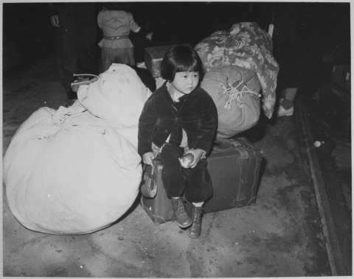 | 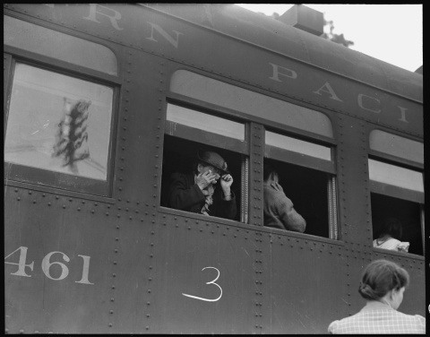
Original WRA caption: A young evacuee of Japanese ancestry waits with the family baggage before leaving by bus for an assembly center in the spring of 1942. Courtesy of the National Archives and Records Administration. | Original WRA caption: Woodland, Yolo County, California. Ten cars of evacuees of Japanese ancestry are now aboard and the doors are closed. Their Caucasian friends and the staff of the Wartime Civil Control Administration stations are watching the departure from the platform. Evacuees are leaving their homes and ranches, in a rich agricultural district, bound for Merced Assembly Center about 125 miles away. Photo by Dorothea Lange. Courtesy National Archives and Records Administration.

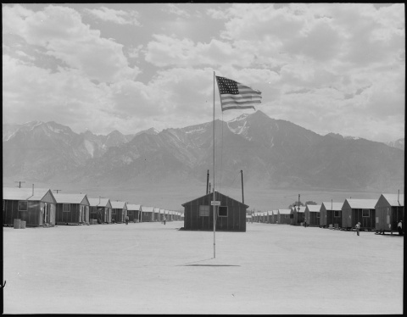
Original WRA caption: Manzanar Relocation center, Manzanar, California. Street scene of barrack homes at this War Relocation Authority Center. The windstorm has subsided and the dust has settled. Photo by Dorothea Lange. Courtesy of the National Archives and Records Administration.

Three men were arrested for, and convicted of, violating these orders and appealed their convictions to the Supreme Court. All three were American citizens. Minoru Yasui was a 26-year-old attorney in Portland, Oregon. After the curfew was imposed on Japanese Americans, he walked the streets of Portland with a copy of the order in hand, determined to challenge its constitutionality. After he asked an officer to arrest him, and the officer told him to go home and not make trouble, Min turned himself in at the local precinct. Gordon Hirabayashi was a 24-year-old student at the University of Washington when he defied the military orders as an act of civil disobedience. He was convicted at trial of violating both the curfew and removal orders. Fred Korematsu was a 22-year-old welder in Oakland, California, when he refused to report for removal. He chose instead to remain with his Italian American fiancé in the place that had always been his home. After his arrest, he was approached by Ernest Besig, Executive Director of the Northern California ACLU, who asked if Fred would be willing to bring a test case to challenge the removal orders; Fred agreed.

Gordon Hirabayashi’s case was the first heard by the Supreme Court; Min Yasui’s case was decided as a companion case. In December 1943, the Court, in a unanimous decision, affirmed Mr. Hirabayashi’s conviction for violating the curfew order. The Court reasoned that military authorities could have reasonably concluded that persons of Japanese ancestry possessed certain racial characteristics that made them subject to influence from Japan and that there was insufficient time to separate those who might be disloyal from the loyal. Because the Court upheld Mr. Hirabayashi’s curfew conviction, it said it did not have to address the constitutionality of his conviction for refusing removal.

A year and a half later, in Korematsu v. United States, the Court upheld the constitutionality of the removal orders. At that point, many Japanese Americans had languished in camp for over 2-1/2 years.

Messrs. Hirabayashi, Yasui, and Korematsu, as well as the rest of the Japanese American community, hoped for a way to challenge these decisions, but there was no appeal from a decision of the Supreme Court.

Forty years later, in 1982, Professor Peter Irons and archival researcher Aiko Herzig-Yoshinaga discovered critical evidence that provided a path to reopening the cases. They found documents in the government’s own archives that showed that it suppressed, altered, and destroyed material evidence while arguing the Hirabayashi, Yasui, and Korematsu cases before the Supreme Court. Messrs. Hirabayashi, Yasui, and Korematsu filed petitions for writ of error coram nobis, a rarely used legal procedure for challenging a conviction after the sentence has been served, seeking to vacate their convictions on the ground of government fraud. The writ of error coram nobis is an ancient writ of English origin (dating back to the 14th century or thereabouts) that allows the correction of errors committed before the court. “Coram nobis” means “before us.”

If you are interested in reading more about the Japanese American wartime cases and the coram nobis cases that reopened them, here are a few resources:

- Six-minute documentaries about wartime Department of Justice attorney Edward Ennis, then-California Attorney General Earl Warren, and archival researcher Aiko Herzig-Yoshinaga, and their roles with regard to the wartime incarceration and cases.

- The award-winning biography of Fred Korematsu by Professor Bannai, Enduring Conviction.
- Radiolab Presents: More Perfect - American Pendulum I, Korematsu v. United States, 10/2/2017.

- One of several interview segments of Gordon Hirabayashi, archived at the Densho Project.

Appendix B - Optional Student Materials
Korematsu v. United States, 323 U.S. 214 (1944)

Mr. Justice Black delivered the opinion of the Court.

The petitioner, an American citizen of Japanese descent, was convicted in a federal district court for remaining in San Leandro, California, a “Military Area,” contrary to Civilian Exclusion Order No. 34 of the Commanding General of the Western Command, U.S. Army, which directed that after May 9, 1942, all persons of Japanese ancestry should be excluded from that area. No question was raised as to petitioner’s loyalty to the United States. The Circuit Court of Appeals affirmed, and the importance of the constitutional question involved caused us to grant certiorari.
It should be noted, to begin with, that all legal restrictions which curtail the civil rights of a single racial group are immediately suspect. That is not to say that all such restrictions are unconstitutional. It is to say that courts must subject them to the most rigid scrutiny. Pressing public necessity may sometimes justify the existence of such restrictions; racial antagonism never can.
In the instant case prosecution of the petitioner was begun by information charging violation of an Act of Congress, of March 21, 1942, which provides that:
* * * whoever shall enter, remain in, leave, or commit any act in any military area or military zone prescribed, under the authority of an Executive order of the President, by the Secretary of War, or by any military commander designated by the Secretary of War, contrary to the restrictions applicable to any such area or zone or contrary to the order of the Secretary of War or any such military commander, shall, if it appears that he knew or should have known of the existence and extent of the restrictions or order and that his act was in violation thereof, be guilty of a misdemeanor and upon conviction shall be liable to a fine of not to exceed $5,000 or to imprisonment for not more than one year, or both, for each offense.
Exclusion Order No. 34, which the petitioner knowingly and admittedly violated, was one of a number of military orders and proclamations, all of which were substantially based upon Executive Order No. 9066. That order, issued after we were at war with Japan, declared that “the successful prosecution of the war requires every possible protection against espionage and against sabotage to national-defense material, national-defense premises, and national-defense utilities. * * *”
One of the series of orders and proclamations, a curfew order, which like the exclusion order here was promulgated pursuant to Executive Order 9066, subjected all persons of Japanese ancestry in prescribed West Coast military areas to remain in their residences from 8 P.M. to 6 A.M. As is the case with the exclusion order here, that prior curfew order was designed as a “protection against espionage and against sabotage.” In Hirabayashi v. United States, we sustained a conviction obtained for violation of the curfew order. The Hirabayashi conviction and this one thus rest on the same 1942 Congressional Act and the same basic executive and military orders, all of which orders were aimed at the twin dangers of espionage and sabotage. * * *
In the light of the principles we announced in the Hirabayashi case, we are unable to conclude that it was beyond the war power of Congress and the Executive to exclude those of Japanese ancestry from the West Coast war area at the time they did. True, exclusion from the area in which one’s home is located is a far greater deprivation than constant confinement to the home from 8 P.M. to 6 A.M. Nothing short of apprehension by the proper military authorities of the gravest imminent danger to the public safety can constitutionally justify either. But exclusion from a threatened area, no less than curfew, has a definite and close relationship to the prevention of espionage and sabotage. The military authorities, charged with the primary responsibility of defending our shores, concluded that curfew provided inadequate protection and ordered exclusion. They did so, as pointed out in our Hirabayashi opinion, in accordance with Congressional authority to the military to say who should, and who should not, remain in the threatened areas.
In this case the petitioner challenges the assumptions upon which we rested our conclusions in the Hirabayashi case. He also urges that by May 1942, when Order No. 34 was promulgated, all danger of Japanese invasion of the West Coast had disappeared. After careful consideration of these contentions we are compelled to reject them.
Here, as in the Hirabayashi case, “* * * we cannot reject as unfounded the judgment of the military authorities and of Congress that there were disloyal members of that population, whose number and strength could not be precisely and quickly ascertained.” * * *
Like curfew, exclusion of those of Japanese origin was deemed necessary because of the presence of an unascertained number of disloyal members of the group, most of whom we have no doubt were loyal to this country. It was because we could not reject the finding of the military authorities that it was impossible to bring about an immediate segregation of the disloyal from the loyal that we sustained the validity of the curfew order as applying to the whole group. In the instant case, temporary exclusion of the entire group was rested by the military on the same ground. The judgment that exclusion of the whole group was for the same reason a military imperative answers the contention that the exclusion was in the nature of group punishment based on antagonism to those of Japanese origin. That there were members of the group who retained loyalties to Japan has been confirmed by investigations made subsequent to the exclusion. Approximately five thousand American citizens of Japanese ancestry refused to swear unqualified allegiance to the United States and to renounce allegiance to the Japanese Emperor, and several thousand evacuees requested repatriation to Japan.
We uphold the exclusion order as of the time it was made and when the petitioner violated it. In doing so, we are not unmindful of the hardships imposed by it upon a large group of American citizens. But hardships are part of war, and war is an aggregation of hardships. All citizens alike, both in and out of uniform, feel the impact of war in greater or lesser measure. Citizenship has its responsibilities as well as its privileges, and in time of war the burden is always heavier. Compulsory exclusion of large groups of citizens from their homes, except under circumstances of direst emergency and peril, is inconsistent with our basic governmental institutions. But when under conditions of modern warfare our shores are threatened by hostile forces, the power to protect must be commensurate with the threatened danger.
* * *
It is now argued that the validity of the exclusion order cannot be considered apart from the orders requiring him, after departure from the area, to report and to remain in an assembly or relocation center. The contention is that we must treat these separate orders as one and inseparable; that, for this reason, if detention in the assembly or relocation center would have illegally deprived the petitioner of his liberty, the exclusion order and his conviction under it cannot stand.
We are thus being asked to pass at this time upon the whole subsequent detention program in both assembly and relocation centers, although the only issues framed at the trial related to petitioner’s remaining in the prohibited area in violation of the exclusion order. Had petitioner here left the prohibited area and gone to an assembly center we cannot say either as a matter of fact or law that his presence in that center would have resulted in his detention in a relocation center. Some who did report to the assembly center were not sent to relocation centers. * * * This illustrates that they pose different problems and may be governed by different principles. The lawfulness of one does not necessarily determine the lawfulness of the others. This is made clear when we analyze the requirements of the separate provisions of the separate orders. These separate requirements were that those of Japanese ancestry (1) depart from the area; (2) report to and temporarily remain in an assembly center; (3) go under military control to a relocation center there to remain for an indeterminate period until released conditionally or unconditionally by the military authorities. Each of these requirements, it will be noted, imposed distinct duties in connection with the separate steps in a complete evacuation program. Had Congress directly incorporated into one Act the language of these separate orders, and provided sanctions for their violations, disobedience of any one would have constituted a separate offense. There is no reason why violations of these orders, insofar as they were promulgated pursuant to Congressional enactment, should not be treated as separate offenses. * * *
Since the petitioner has not been convicted of failing to report or to remain in an assembly or relocation center, we cannot in this case determine the validity of those separate provisions of the order. It is sufficient here for us to pass upon the order which petitioner violated. To do more would be to go beyond the issues raised, and to decide momentous questions not contained within the framework of the pleadings or the evidence in this case. It will be time enough to decide the serious constitutional issues which petitioner seeks to raise when an assembly or relocation order is applied or is certain to be applied to him, and we have its terms before us.
Some of the members of the Court are of the view that evacuation and detention in an Assembly Center were inseparable. After May 3, 1942, the date of Exclusion Order No. 34, Korematsu was under compulsion to leave the area not as he would choose but via an Assembly Center. The Assembly Center was conceived as a part of the machinery for group evacuation. The power to exclude includes the power to do it by force if necessary. And any forcible measure must necessarily entail some degree of detention or restraint whatever method of removal is selected. But whichever view is taken, it results in holding that the order under which petitioner was convicted was valid.
It is said that we are dealing here with the case of imprisonment of a citizen in a concentration camp solely because of his ancestry, without evidence or inquiry concerning his loyalty and good disposition towards the United States. Our task would be simple, our duty clear, were this a case involving the imprisonment of a loyal citizen in a concentration camp because of racial prejudice. Regardless of the true nature of the assembly and relocation centers—and we deem it unjustifiable to call them concentration camps with all the ugly connotations that term implies—we are dealing specifically with nothing but an exclusion order. To cast this case into outlines of racial prejudice, without reference to the real military dangers which were presented, merely confuses the issue.
Korematsu was not excluded from the Military Area because of hostility to him or his race. He was excluded because we are at war with the Japanese Empire, because the properly constituted military authorities feared an invasion of our West Coast and felt constrained to take proper security measures, because they decided that the military urgency of the situation demanded that all citizens of Japanese ancestry be segregated from the West Coast temporarily, and finally, because Congress, reposing its confidence in this time of war in our military leaders—as inevitably it must—determined that they should have the power to do just this. There was evidence of disloyalty on the part of some, the military authorities considered that the need for action was great, and time was short. We cannot—by availing ourselves of the calm perspective of hindsight—now say that at that time these actions were unjustified.

Affirmed.

[Concurring opinion of Mr. Justice Frankfurter is omitted].

[Mr. Justice Roberts dissented on the ground that the Korematsu case was not a limited intrusion like the curfew order in Hirabayashi. Instead, the government’s orders involved imprisonment based on race. A brief excerpt follows].
I dissent, because I think the indisputable facts exhibit a clear violation of Constitutional rights.
This is not a case of keeping people off the streets at night as was Hirabayashi v. United States, nor a case of temporary exclusion of a citizen from an area for his own safety or that of the community, nor a case of offering him an opportunity to go temporarily out of an area where his presence might cause danger to himself or to his fellows. On the contrary, it is the case of convicting a citizen as a punishment for not submitting to imprisonment in a concentration camp, based on his ancestry, and solely because of his ancestry, without evidence or inquiry concerning his loyalty and good disposition towards the United States. If this be a correct statement of the facts disclosed by this record, and facts of which we take judicial notice, I need hardly labor the conclusion that Constitutional rights have been violated.
The Government’s argument, and the opinion of the court, in my judgment, erroneously divide that which is single and indivisible and thus make the case appear as if the petitioner violated a Military Order, sanctioned by Act of Congress, which excluded him from his home, by refusing voluntarily to leave and, so, knowingly and intentionally, defying the order and the Act of Congress.
[Eds: Justice Roberts addressed how, at the time the exclusion order was issued, Mr. Korematsu was also subject to a “freeze” order prohibiting him from leaving the area except as directed by further military].
The obvious purpose of the orders made, taken together, was to drive all citizens of Japanese ancestry into Assembly Centers within the zones of their residence, under pain of criminal prosecution. * * *
[T]he * * * the exclusion was but a part of an overall plan for forcible detention. This case cannot, therefore, be decided on any such narrow ground as the possible validity of a Temporary Exclusion Order under which the residents of an area are given an opportunity to leave and go elsewhere in their native land outside the boundaries of a military area. To make the case turn on any such assumption is to shut our eyes to reality.
* * * I would reverse the judgment of conviction.

Mr. Justice Murphy, dissenting.
This exclusion of “all persons of Japanese ancestry, both alien and non-alien,” from the Pacific Coast area on a plea of military necessity in the absence of martial law ought not to be approved. Such exclusion goes over “the very brink of constitutional power” and falls into the ugly abyss of racism.
In dealing with matters relating to the prosecution and progress of a war, we must accord great respect and consideration to the judgments of the military authorities who are on the scene and who have full knowledge of the military facts. The scope of their discretion must, as a matter of necessity and common sense, be wide. And their judgments ought not to be overruled lightly by those whose training and duties ill-equip them to deal intelligently with matters so vital to the physical security of the nation.
At the same time, however, it is essential that there be definite limits to military discretion, especially where martial law has not been declared. Individuals must not be left impoverished of their constitutional rights on a plea of military necessity that has neither substance nor support. Thus, like other claims conflicting with the asserted constitutional rights of the individual, the military claim must subject itself to the judicial process of having its reasonableness determined and its conflicts with other interests reconciled. “What are the allowable limits of military discretion, and whether or not they have been over-stepped in a particular case, are judicial questions.” Sterling v. Constantin, 287 U.S. 378, 401 [(1932)].
The judicial test of whether the Government, on a plea of military necessity, can validly deprive an individual of any of his constitutional rights is whether the deprivation is reasonably related to a public danger that is so “immediate, imminent, and impending” as not to admit of delay and not to permit the intervention of ordinary constitutional processes to alleviate the danger. Civilian Exclusion Order No. 34, banishing from a prescribed area of the Pacific Coast “all persons of Japanese ancestry, both alien and non-alien,” clearly does not meet that test. Being an obvious racial discrimination, the order deprives all those within its scope of the equal protection of the laws as guaranteed by the Fifth Amendment. It further deprives these individuals of their constitutional rights to live and work where they will, to establish a home where they choose and to move about freely. In excommunicating them without benefit of hearings, this order also deprives them of all their constitutional rights to procedural due process. Yet no reasonable relation to an “immediate, imminent, and impending” public danger is evident to support this racial restriction which is one of the most sweeping and complete deprivations of constitutional rights in the history of this nation in the absence of martial law.
It must be conceded that the military and naval situation in the spring of 1942 was such as to generate a very real fear of invasion of the Pacific Coast, accompanied by fears of sabotage and espionage in that area. The military command was therefore justified in adopting all reasonable means necessary to combat these dangers. In adjudging the military action taken in light of the then apparent dangers, we must not erect too high or too meticulous standards; it is necessary only that the action have some reasonable relation to the removal of the dangers of invasion, sabotage and espionage. But the exclusion, either temporarily or permanently, of all persons with Japanese blood in their veins has no such reasonable relation. And that relation is lacking because the exclusion order necessarily must rely for its reasonableness upon the assumption that all persons of Japanese ancestry may have a dangerous tendency to commit sabotage and espionage and to aid our Japanese enemy in other ways. It is difficult to believe that reason, logic or experience could be marshaled in support of such an assumption.
That this forced exclusion was the result in good measure of this erroneous assumption of racial guilt rather than bona fide military necessity is evidenced by the Commanding General’s Final Report on the evacuation from the Pacific Coast area. In it he refers to all individuals of Japanese descent as “subversive,” as belonging to “an enemy race” whose “racial strains are undiluted,” and as constituting “over 112,000 potential enemies * * * at large today” along the Pacific Coast. In support of this blanket condemnation of all persons of Japanese descent, however, no reliable evidence is cited to show that such individuals were generally disloyal, or had generally so conducted themselves in this area as to constitute a special menace to defense installations or war industries, or had otherwise by their behavior furnished reasonable ground for their exclusion as a group.
Justification for the exclusion is sought, instead, mainly upon questionable racial and sociological grounds not ordinarily within the realm of expert military judgment, supplemented by certain semi-military conclusions drawn from an unwarranted use of circumstantial evidence. Individuals of Japanese ancestry are condemned because they are said to be “a large, unassimilated, tightly knit racial group, bound to an enemy nation by strong ties of race, culture, custom and religion.”₄
They are claimed to be given to “emperor worshipping ceremonies”₅ and to “dual citizenship.”₆ Japanese language schools and allegedly pro-Japanese organizations are cited as evidence of possible group disloyalty,₇ together with facts as to certain persons being educated and residing at length in Japan. It is intimated that many of these individuals deliberately resided “adjacent to strategic points,” thus enabling them “to carry into execution a tremendous program of sabotage on a mass scale should any considerable number of them have been inclined to do so.”₉

₄ To the extent that assimilation is a problem, it is largely the result of certain social customs and laws of the American general public. Studies demonstrate that persons of Japanese descent are readily susceptible to integration in our society if given the opportunity. Strong, The Second-Generation Japanese Problem (1934); Smith, Americans in Process (1937); Mears, Resident Orientals on the American Pacific Coast (1928); Millis, The Japanese Problem in the United States (1942). The failure to accomplish an ideal status of assimilation, therefore, cannot be charged to the refusal of these persons to become Americanized or to their loyalty to Japan. And the retention by some persons of certain customs and religious practices of their ancestors is no criterion of their loyalty to the United States.
₅ Final Report, pp. 10-11. No sinister correlation between the emperor worshipping activities and disloyalty to America was shown.
₆ Final Report, p. 22. The charge of “dual citizenship” springs from a misunderstanding of the simple fact that Japan in the past used the doctrine of jus sanguinis, as she had a right to do under international law, and claimed as her citizens all persons born of Japanese nationals wherever located. Japan has greatly modified this doctrine, however, by allowing all Japanese born in the United States to renounce any claim of dual citizenship and by releasing her claim as to all born in the United States after 1925. See Freeman, Genesis, Exodus, and Leviticus: Genealogy, Evacuation, and Law, 28 Cornell L.Q. 414, 447-8, and authorities there cited; McWilliams, Prejudice, 123-4 (1944).
₇ Final Report, pp. 12-13. We have had various foreign language schools in this country for generations without considering their existence as ground for racial discrimination. No subversive activities or teachings have been shown in connection with the Japanese schools. McWilliams, Prejudice, 121-3 (1944).
₉ Final Report, p. 10; see also pp. vii, 9, 15-17. This insinuation, based purely upon speculation and circumstantial evidence, completely overlooks the fact that the main geographic pattern of Japanese population was fixed many years ago with reference to economic, social and soil conditions. Limited occupational outlets and social pressures encouraged their concentration near their initial points of entry on the Pacific Coast. That these points may now be near certain strategic military and industrial areas is no proof of a diabolical purpose on the part of Japanese Americans. See McWilliams, Prejudice, 119-121 (1944); H.R. Rep. No. 2124 (77th Cong., 2d Sess.), 59-93.

The need for protective custody is also asserted. The report refers without identity to “numerous incidents of violence” as well as to other admittedly unverified or cumulative incidents. From this, plus certain other events not shown to have been connected with the Japanese Americans, it is concluded that the “situation was fraught with danger to the Japanese population itself” and that the general public “was ready to take matters into its own hands.”₁₀
Finally, it is intimated, though not directly charged or proved, that persons of Japanese ancestry were responsible for three minor isolated shellings and bombings of the Pacific Coast area,₁₁ as well as for unidentified radio transmissions and night signaling.
The main reasons relied upon by those responsible for the forced evacuation, therefore, do not prove a reasonable relation between the group characteristics of Japanese Americans and the dangers of invasion, sabotage and espionage. The reasons appear, instead, to be largely an accumulation of much of the misinformation, half-truths and insinuations that for years have been directed against Japanese Americans by people with racial and economic prejudices—the same people who have been among the foremost advocates of the evacuation.₁₂ A military judgment based upon such racial and sociological considerations is not entitled to the great weight ordinarily given the
judgments based upon strictly military considerations. Especially is this so when every charge relative to race, religion, culture, geographical location, and legal and economic status has been substantially discredited by independent studies made by experts in these matters.
The military necessity which is essential to the validity of the evacuation order thus resolves itself into a few intimations that certain individuals actively aided the enemy, from which it is inferred that the entire group of Japanese Americans could not be trusted to be or remain loyal to the United States. No one denies, of course, that there were some disloyal persons of Japanese descent on the Pacific Coast who did all in their power to aid their ancestral land. Similar disloyal activities have been engaged in by

₁₀ Final Report, pp. 8-9. This dangerous doctrine of protective custody, as proved by recent European history, should have absolutely no standing as an excuse for the deprivation of the rights of minority groups. See H.R. Rep. No. 1911 (77th Cong., 2d Sess.) 1-2. Cf. H.R. Rep. No. 2124 (77th Cong., 2d Sess.) 145-7. In this instance, moreover, there are only two minor instances of violence on record involving persons of Japanese ancestry. McWilliams, What About Our Japanese-Americans? 8 (Public Affairs Pamphlets, No. 91, 1944).
₁₁ Final Report, p. 18. One of these incidents (the reputed dropping of incendiary bombs on an Oregon forest) occurred on Sept. 9, 1942—a considerable time after the Japanese Americans had been evacuated from their homes and placed in Assembly Centers. See N.Y. Times, Sept. 15, 1942, at 1, col. 3.
₁₂ Special interest groups were extremely active in applying pressure for mass evacuation. See H.R. Rep. No. 2124 (77th Cong., 2d Sess.) 154-6; McWilliams, Prejudice, 126-8 (1944). Mr. Austin E. Anson, managing secretary of the Salinas Vegetable Grower-Shipper Association, has frankly admitted that “We’re charged with wanting to get rid of the Japs for selfish reasons . . . . We do. It’s a question of whether the white man lives on the Pacific Coast or the brown men. They came into this valley to work, and they stayed to take over . . . . They undersell the white man in the markets . . . . They work their women and children while the white farmer has to pay wages for his help. If all the Japs were removed tomorrow, we’d never miss them in two weeks, because the white farmers can take over and produce everything the Jap grows. And we don’t want them back when the war ends, either.” Quoted by Taylor in his article The People Nobody Wants, 214 Sat. Eve. Post 24, 66 (May 9, 1942).

many persons of German, Italian and even more pioneer stock in our country. But to infer that examples of individual disloyalty prove group disloyalty and justify discriminatory action against the entire group is to deny that under our system of law individual guilt is the sole basis for deprivation of rights.
Moreover, this inference, which is at the very heart of the evacuation orders, has been used in support of the abhorrent and despicable treatment of minority groups by the dictatorial tyrannies which this nation is now pledged to destroy. To give constitutional sanction to that inference in this case, however well-intentioned may have been the military command on the Pacific Coast, is to adopt one of the cruelest of the rationales used by our enemies to destroy the dignity of the individual and to encourage and open the door to discriminatory actions against other minority groups in the passions of tomorrow.
No adequate reason is given for the failure to treat these Japanese Americans on an individual basis by holding investigations and hearings to separate the loyal from the disloyal, as was done in the case of persons of German and Italian ancestry. See House Report No. 2124 (77th Cong., 2d Sess.) 247-52. It is asserted merely that the loyalties of this group “were unknown and time was of the essence.” Yet nearly four months elapsed after Pearl Harbor before the first exclusion order was issued; nearly eight
months went by until the last order was issued; and the last of these “subversive” persons was not actually removed until almost eleven months had elapsed. Leisure and
deliberation seem to have been more of the essence than speed. And the fact that conditions were not such as to warrant a declaration of martial law adds strength to the belief that the factors of time and military necessity were not as urgent as they have been represented to be.
Moreover, there was no adequate proof that the Federal Bureau of Investigation and the military and naval intelligence services did not have the espionage and sabotage situation well in hand during this long period. Nor is there any denial of the fact that not one person of Japanese ancestry was accused or convicted of espionage or sabotage after Pearl Harbor while they were still free,₁₅ a fact which is some evidence of the loyalty of the vast majority of these individuals and of the effectiveness of the established methods of combatting these evils. It seems incredible that under these circumstances it would have been impossible to hold loyalty hearings for the mere 112,000 persons involved—or at least for the 70,000 American citizens—especially when a large part of this number represented children and elderly men and women.₁₆ Any inconvenience that may have accompanied an attempt to conform to procedural due process cannot be said to justify violations of constitutional rights of individuals.

₁₅ The Final Report, p. 34, makes the amazing statement that as of February 14, 1942: “The very fact that no sabotage has taken place to date is a disturbing and confirming indication that such action will be taken.” Apparently, in the minds of the military leaders, there was no way that the Japanese Americans could escape the suspicion of sabotage.
₁₆ During a period of six months, the 112 alien tribunals or hearing boards set up by the British Government shortly after the outbreak of the present war summoned and examined approximately 74,000 German and Austrian aliens. These tribunals determined whether each individual enemy alien was a real enemy of the Allies or only a “friendly enemy.” About 64,000 were freed from
internment and from any special restrictions, and only 2,000 were interned. Kempner, The Enemy Alien Problem in the Present War, 34 A. J. Int’l L. 443, 444-46; H.R. Rep. No. 2124 (77th Cong., 2d Sess.), 280-1.
I dissent, therefore, from this legalization of racism. Racial discrimination in any form and in any degree has no justifiable part whatever in our democratic way of life. It is unattractive in any setting but it is utterly revolting among a free people who have embraced the principles set forth in the Constitution of the United States. All residents of this nation are kin in some way by blood or culture to a foreign land. Yet they are primarily and necessarily a part of the new and distinct civilization of the United States. They must accordingly be treated at all times as the heirs of the American experiment and as entitled to all the rights and freedoms guaranteed by the Constitution.

Mr. Justice Jackson, dissenting.
Korematsu was born on our soil, of parents born in Japan. The Constitution makes him a citizen of the United States by nativity and a citizen of California by residence.
No claim is made that he is not loyal to this country. * * *Korematsu, however, has been convicted of an act not commonly a crime. It consists merely of being present in the state whereof he is a citizen, near the place where he was born, and where all his life he has lived. * * *
Had Korematsu been one of four—the others being, say, a German alien enemy, an Italian alien enemy, and a citizen of American-born ancestors, convicted of treason but out on parole—only Korematsu’s presence would have violated the order. The difference between their innocence and his crime would result, not from anything he did, said, or thought, different than they, but only in that he was born of different racial stock.
Now, if any fundamental assumption underlies our system, it is that guilt is personal and not inheritable. * * * But here is an attempt to make an otherwise innocent act a
crime merely because this prisoner is the son of parents as to whom he had no choice, and belongs to a race from which there is no way to resign. If Congress in peace-time legislation should enact such a criminal law, I should suppose this Court would refuse to enforce it.
But the “law” which this prisoner is convicted of disregarding is not found in an act of Congress, but in a military order. Neither the Act of Congress nor the Executive Order of the President, nor both together, would afford a basis for this conviction. It rests on the orders of General DeWitt. And it is said that if the military commander had reasonable military grounds for promulgating the orders, they are constitutional and become law, and the Court is required to enforce them. There are several reasons why I cannot subscribe to this doctrine.
It would be impracticable and dangerous idealism to expect or insist that each specific military command in an area of probable operations will conform to conventional tests of constitutionality. When an area is so beset that it must be put under military control at all, the paramount consideration is that its measures be successful, rather than legal. * * * The very essence of the military job is to marshal physical force, to remove every obstacle to its effectiveness, to give it every strategic advantage. Defense measures will not, and often should not, be held within the limits that bind civil authority in peace. No court can require such a commander in such circumstances to act as a reasonable man; he may be unreasonably cautious and exacting. Perhaps he should be. But a commander in temporarily focusing the life of a community on defense is carrying out a military program; he is not making law in the sense the courts know the term. He issues orders, and they may have a certain authority as military commands, although they may be very bad as constitutional law.
But if we cannot confine military expedients by the Constitution, neither would I distort the Constitution to approve all that the military may deem expedient. That is what the Court appears to be doing, whether consciously or not. I cannot say, from any evidence before me, that the orders of General DeWitt were nor reasonably expedient military precautions, nor could I say that they were. But even if they were permissible military procedures, I deny that it follows that they are constitutional. If, as the Court holds, it does follow, then we may as well say that any military order will be constitutional and have done with it.
The limitation under which courts always will labor in examining the necessity for a military order are illustrated by this case. How does the Court know that these orders have a reasonable basis in necessity? No evidence whatever on that subject has been taken by this or any other court. There is sharp controversy as to the credibility of the DeWitt report. So the Court, having no real evidence before it, has no choice but to accept General DeWitt’s own unsworn, self-serving statement, untested by any cross-examination, that what he did was reasonable. And thus it will always be when courts try to look into the reasonableness of a military order.
In the very nature of things, military decisions are not susceptible of intelligent judicial appraisal. They do not pretend to rest on evidence, but are made on information that often would not be admissible and on assumptions that could not be proved. Information in support of an order could not be disclosed to courts without danger that it would reach the enemy. Neither can courts act on communications made in confidence. Hence courts can never have any real alternative to accepting the mere declaration of the authority that issued the order that it was reasonably necessary from a military viewpoint.
Much is said of the danger to liberty from the Army program for deporting and detaining these citizens of Japanese extraction. But a judicial construction of the due process clause that will sustain this order is a far more subtle blow to liberty than the promulgation of the order itself. A military order, however unconstitutional, is not apt to last longer than the military emergency. Even during that period a succeeding commander may revoke it all. But once a judicial opinion rationalizes such an order to show that it conforms to the Constitution, or rather rationalizes the Constitution to show that the Constitution sanctions such an order, the Court for all time has validated the principle of racial discrimination in criminal procedure and of transplanting American citizens. The principle then lies about like a loaded weapon ready for the hand of any authority that can bring forward a plausible claim of an urgent need. Every repetition imbeds that principle more deeply in our law and thinking and expands it to new purposes. * * * Nothing better illustrates this danger than does the Court’s opinion in this case.
It argues that we are bound to uphold the conviction of Korematsu because we upheld one in Hirabayashi v. United States, 320 U.S. 81, when we sustained these orders in so far as they applied a curfew requirement to a citizen of Japanese ancestry. I think we should learn something from that experience.
In that case we were urged to consider only the curfew feature, that being all that technically was involved, because it was the only count necessary to sustain Hirabayashi’s conviction and sentence. We yielded, and the Chief Justice guarded the opinion as carefully as language will do. * * * “We decide only the issue as we have defined it—we decide only that the curfew order as applied, and at the time it was applied, was within the boundaries of the war power.” 320 U.S. 81 at 102. * * * However, in spite of our limiting words we did validate a discrimination on the basis of ancestry for mild and temporary deprivation of liberty. Now the principle of racial discrimination is pushed from support of mild measures to very harsh ones, and from temporary deprivations to indeterminate ones. And the precedent which it is said requires us to do so is Hirabayashi. The Court is now saying that in Hirabayashi we did decide the very things we there said we were not deciding. Because we said that these citizens could be made to stay in their homes during the hours of dark, it is said we must require them to leave home entirely; and if that, we are told they may also be taken into custody for deportation; and if that, it is argued they may also be held for some undetermined time in detention camps. How far the principle of this case would be extended before plausible reasons would play out, I do not know. * * *
My duties as a justice as I see them do not require me to make a military judgment as to whether General DeWitt’s evacuation and detention program was a reasonable military necessity. I do not suggest that the courts should have attempted to interfere with the Army in carrying out its task. But I do not think they may be asked to execute a military expedient that has no place in law under the Constitution. I would reverse the judgment and discharge the prisoner.

Appendix C – Optional Student Materials
Introduction from Fred Korematsu’s Petition for Writ of Error Coram Nobis (identical petitions were filed on behalf of Gordon Hirabayashi in Seattle, Washington, and Minoru Yasui in Portland, Oregon)

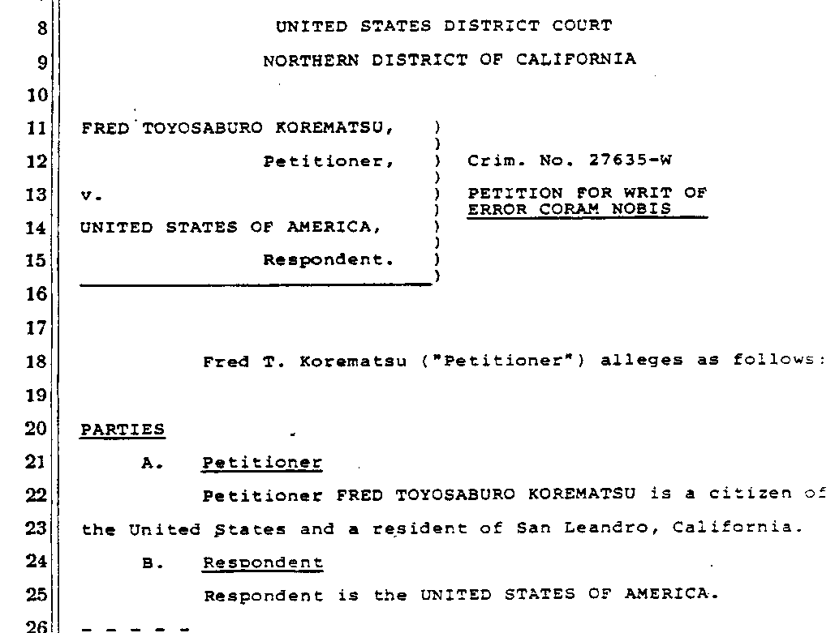

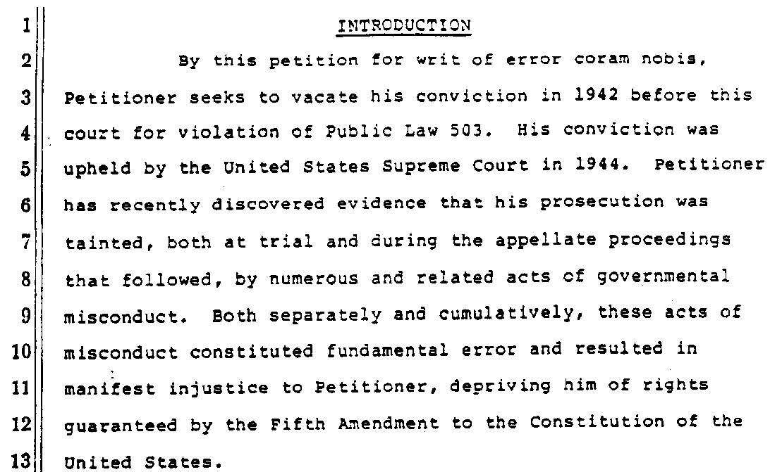

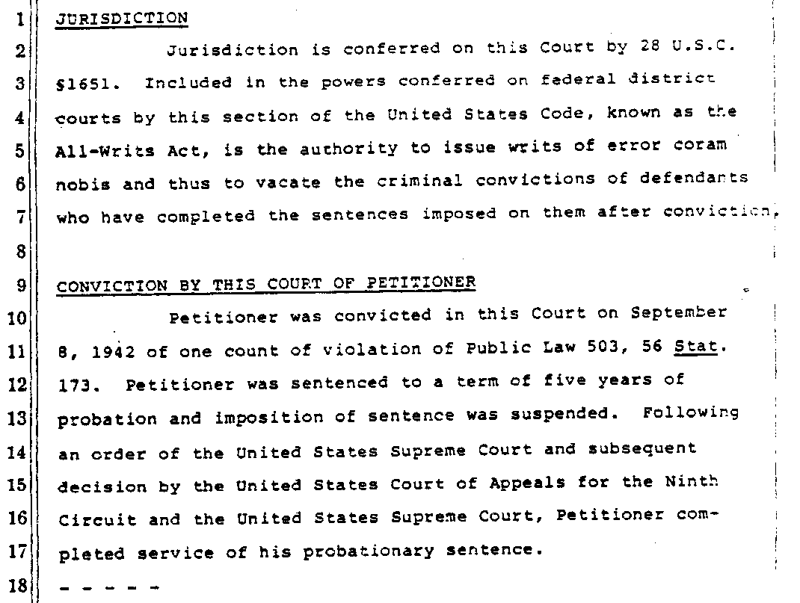

[Eds.: continuation of text:]

A. Relation of This Petition to Those Filed on
Behalf of Gordon Hirabayashi and Minoru Yasui
This is an extraordinary petition in many ways.
First, it seeks to vacate a conviction that led to a historic and widely cited and debated opinion of the Supreme Court. Second, the allegations of governmental misconduct made below raise the most fundamental questions of the ethical and legal obligations of government officials. Third, the alleged misconduct was committed not only before this court but also before the United States Supreme Court. Fourth, this petition is identical to separate petitions being filed on behalf of Gordon Hirabayashi and Minoru Yasui in the federal district courts in Seattle, Washington and Portland, Oregon, respectively. Hirabayashi and Yasui were also convicted in 1942 of violation of Public Law 503 and their convictions were upheld by the Supreme Court in 1943. * * *

C. Summary of Acts of Governmental Misconduct Alleged by Petitioners
* * *
Point One: Officials of the War Department altered and destroyed evidence and withheld knowledge of this evidence from the Department of Justice and the Supreme Court. In April 1943, General John L. DeWitt, who headed the Western Defense Command and issued the military orders at issue in Petitioners’ cases, submitted an official report to the War Department on the evacuation and incarceration program. Justice Department officials had requested access to this Final Report for use in the government’s Supreme Court briefs in Hirabayashi and Yasui. When War Department officials discovered that the report contained statements contradicting representations made by the Justice Department to the courts, they altered these statements. They subsequently concealed records of the report’s receipt, destroyed records of its preparation, created records that falsely identified a revised version as the only report, and withheld the original version from the Justice Department. These acts were committed with knowledge that the contents of this report were material to the cases pending before the Supreme Court.
Point Two: Officials of the War Department and the Department of Justice suppressed evidence relative to the loyalty of Japanese Americans and to the alleged commission by them of acts of espionage. The government relied in Petitioners’ cases on purported evidence of widespread disloyalty among the Japanese Americans and the alleged commission by them of acts of espionage. Presented to the courts as justification of the curfew and exclusion orders at issue, these claims were made in the Final Report of General DeWitt. Responsible officials knew that these claims were false. Reports of the Office of Naval Intelligence directly refuted DeWitt’s disloyalty claims, while reports of DeWitt’s own intelligence staff and of the Federal Bureau of Investigation and the Federal Communications Commission directly refuted DeWitt’s espionage claims. Although the Final Report was before the Supreme Court in Petitioners’ cases, these exculpatory reports were withheld from the Court despite the protest of government attorneys that such action constituted “suppression of evidence.”
Point Three: Government officials failed to advise the Supreme Court of the falsity of the allegations in the Final Report of General DeWitt. When certain Justice Department attorneys learned of the exculpatory evidence discussed in Point Two [supra], they attempted to alert the Supreme Court to its existence and the falsity of the Final Report of General DeWitt. Their effort took the form of a crucial footnote in the government’s Korematsu brief to the Court. This footnote explicitly repudiated DeWitt’s espionage claims and advised the Court of the existence of countering evidence. Before submission of the brief, War Department officials intervened with the Solicitor General and urged removal of the footnote. As a result of this intervention, the Solicitor General halted printing of the brief and directed that the footnote be revised to the War Department’s satisfaction. The Korematsu brief accordingly failed to advise the Court of the falsity of DeWitt’s claims and thus misled the Court.
Point Four: The government’s abuse of the doctrine of judicial notice and the manipulation of amicus briefs constituted a fraud upon the courts. Justice Department and War Department officials undertook separate but related efforts to present a false and misleading record to the courts in Petitioners’ cases.
Even before trial of these cases, Justice Department officials decided to utilize the doctrine of judicial notice in presenting “evidence” that the “racial characteristics” of Japanese Americans predisposed them to disloyalty. Despite the rebuff of one trial judge, and knowledge by Justice Department attorneys that countering evidence existed, such tainted “evidence” was included in the Supreme Court briefs in Petitioners’ cases. In addition, War Department officials made available to the attorneys general of the West Coast states the Final Report withheld from the Justice Department, and delegated a military officer to assist in preparing the amicus briefs submitted by these states to the Supreme Court. Justice Department attorneys later learned of these acts and concluded they were unlawful, but failed to report these acts to the Supreme Court.
Point Five: Petitioners are also entitled to relief on the ground that their convictions are based on governmental orders that violate current constitutional standards. The acts of misconduct alleged in the preceding Points provide ample ground for the vacation of Petitioners’ convictions. With Petitioners’ cases before this Court through the instant petition, the application of current constitutional standards provides an additional ground for vacation. The racial classification involved in the military orders at issue is subject to the “strict scrutiny” standard laid out in subsequent Supreme Court opinions. The government now has the task of proving that such a racial classification is essential to fulfill a compelling governmental interest and that no less restrictive alternative is available. Petitioners argue that application of this standard requires vacation of their convictions. * * *

Prayer for Relief
Petitioners respectfully submit that it would be impossible to find any other instance in American history of such a long standing, pervasive and unlawful governmental scheme designed to mislead and defraud the courts and the nation. By the misconduct set forth in detail above, the United States deprived petitioners of their rights to fair judicial proceedings guaranteed by the Fifth Amendment to the United States Constitution. Although successful to date, this fundamental and egregious denial of civil liberties cannot be permitted to stand uncorrected.
Wherefore, petitioner Fred Toyosaburo Korematsu respectfully prays:
1. That judgment of conviction be vacated;
2. That the military orders under which he was convicted be declared unconstitutional;
3. That his indictment be dismissed;
4. For costs of suit and reasonable attorneys’ fees;
5. For such other relief as may be just and proper.

Dated: January 19, 1983
Respectfully submitted,
By: Peter Irons
By: Dale Minami
Minami, Tomine & Lew

[Eds.: Other attorneys of record for Fred Korematsu included Dennis W. Hayashi, Donald K. Tamaki, and Michael J. Wong of the Asian Law Caucus; Robert L. Rusky of Hanson, Bridgett, Marcus, Vlahos & Stromberg; Peter Irons; Karen N. Kai; Russell Matsumoto of Maniwa & Matsumoto; Dale Minami and Lorraine K. Bannai of Minami, Tomine & Lew; Eric K. Yamamoto, formerly of Case, Kay and Lynch, Honolulu, Hawai‘i; and Edward Chen of Coblentz, Cahen, McCabe & Breyer.]

Appendix D – Optional Student Materials
Memo from Assistant Attorney General Edward Ennis warning
the Solicitor General that suppression of the Report of the Office of Naval Intelligence may constitute suppression of evidence

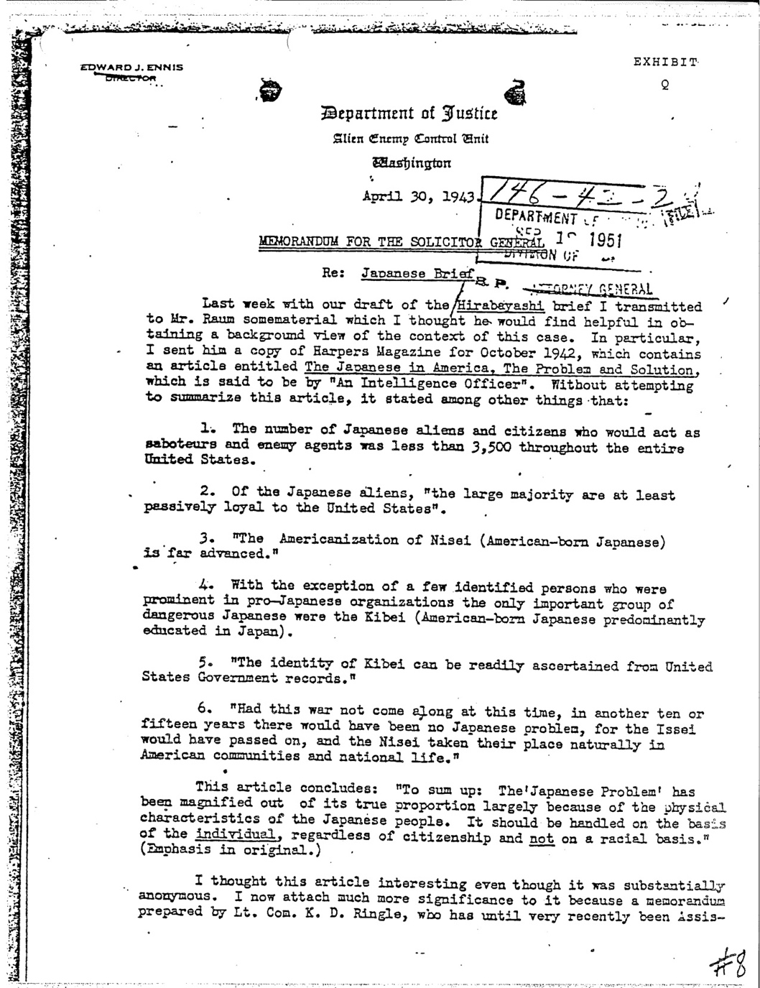
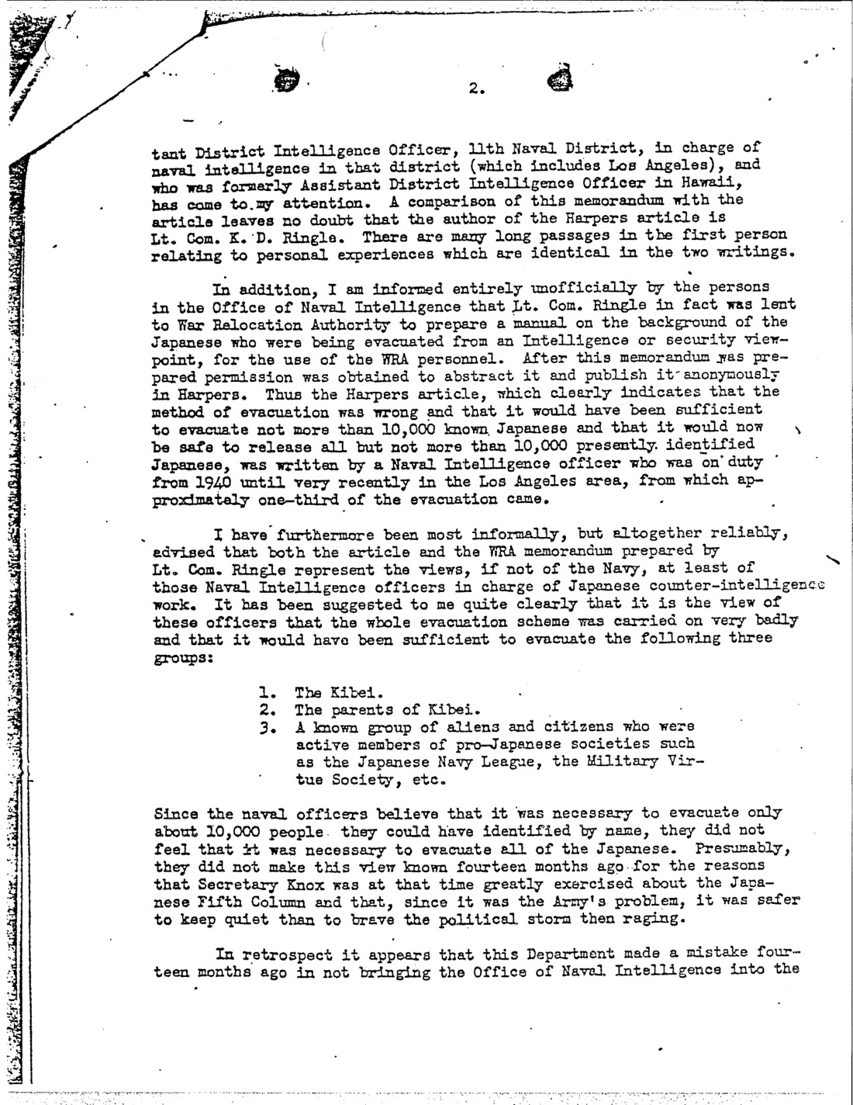
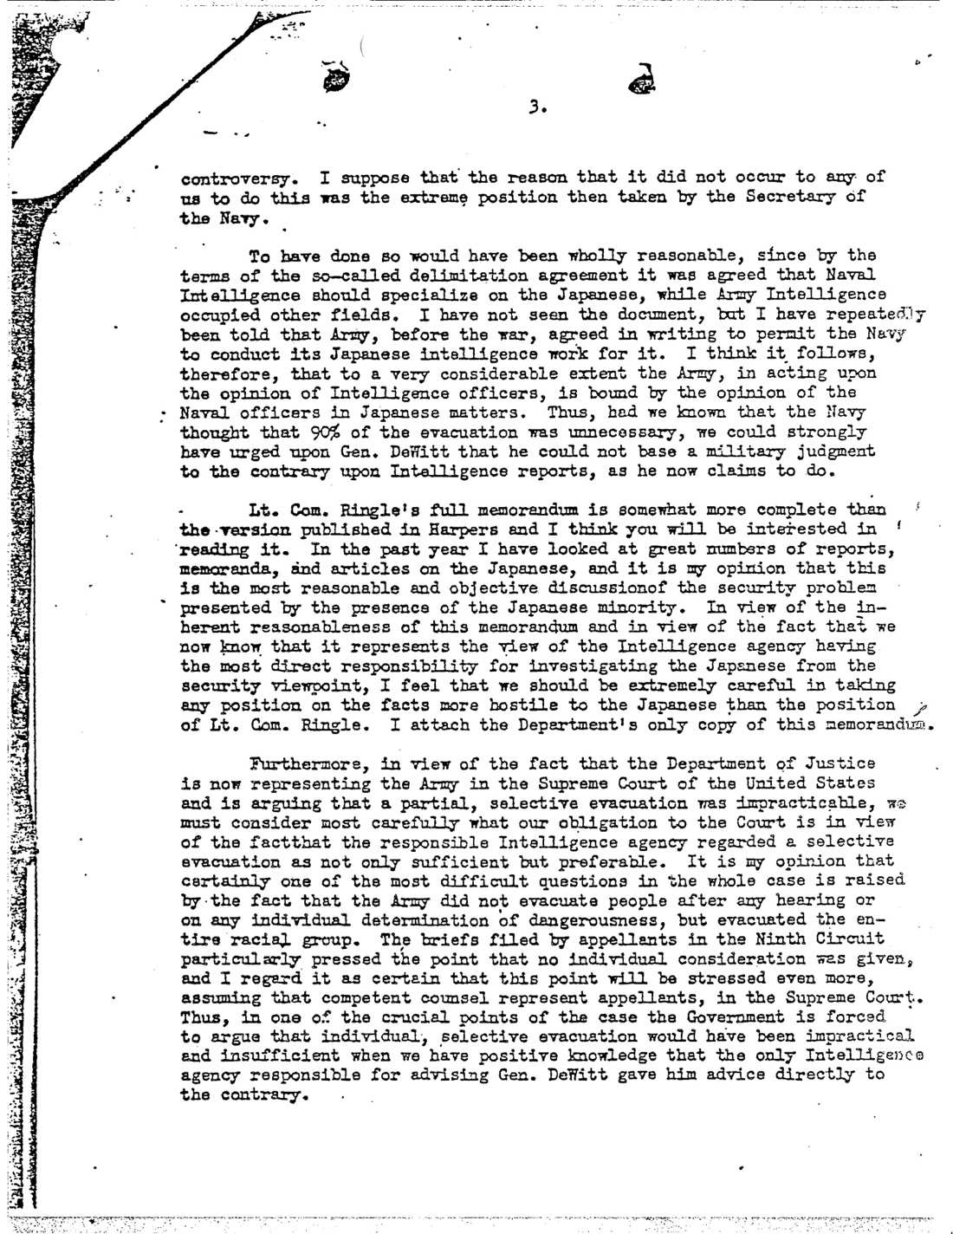
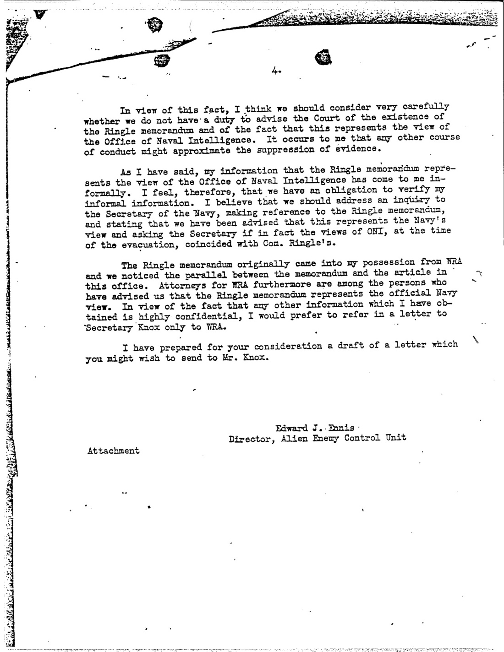

Appendix E
Optional Student Materials
Memo from Theodore Smith stating that he destroyed the original version of the DeWitt Report

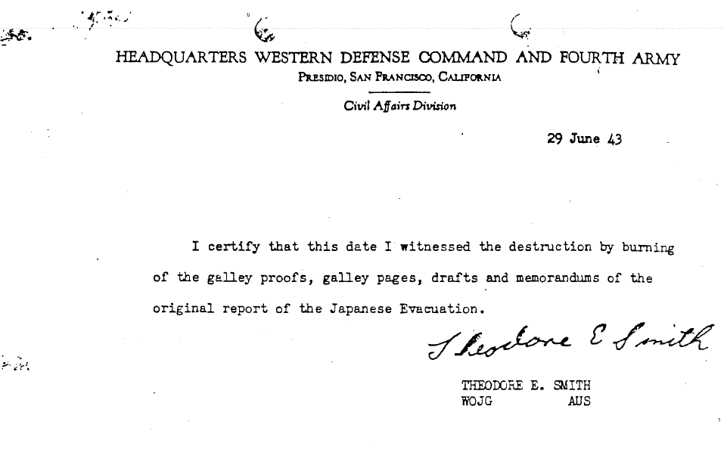

This materials are made possible by a grant from the Minami, Tamaki, Yamauchi, Kwok, and Lee Foundation. You are welcome to use these materials without charge, in whole or in part; it would be helpful if you let Professor Bannai know if you intend to use them. Many thanks to colleagues at Seattle University School of Law who prepared a 1L Orientation using the wartime incarceration for its orientation, including Associate Dean of Students Donna Claxton Deming and Prof. Mary Bowman.
Korematsu v. United States, 323 U.S. 214 (1944), conviction vacated, 584 F. Supp. 1406 (N.D. Cal. 1984). The 1944 Supreme Court Korematsu decision will be referred to as Korematsu I.
Korematsu v. United States, 584 F. Supp. 1406 (N.D. Cal. 1984)(hereinafter Korematsu II).
Korematsu v. United States, 323 U.S. 214 (1944), conviction vacated, 584 F. Supp. 1406 (N.D. Cal. 1984). The 1944 Supreme Court Korematsu decision will be referred to as Korematsu I.
Korematsu v. United States, 584 F. Supp. 1406 (N.D. Cal. 1984)(hereinafter Korematsu II).
Hirabayashi v. United States, 320 U.S. 81 (1943), conviction vacated, 828 F.2d 591 (9th Cir. 1987).
Korematsu v. United States, 323 U.S. 214 (1944), conviction vacated, 584 F. Supp. 1406 (N.D. Cal. 1984).
Only some of the footnotes in the opinion are included.
For a copy of the full Petition, the Table of Exhibits, and the exhibits, see https://ddr.densho.org/ddr-densho-405/.
Memorandum from Edward Ennis, Head of the Dep’t. of Just., Alien Enemy Control Unit, to Solic. Gen. Charles Fahy (Apr. 30, 1943), Ex. Q of the Coram Nobis Petitions (1983), available at Coram Nobis Exhibit Q, Densho Dig. Repository, http://ddr.densho.org/ddr-densho-405-19/.

